Class: COMP 3090 - Database I

Name: DangNhi Ngoc Ngo

Email: DangNhi_Ngo@student.uml.edu

Student ID: 01553277

**HOMEWORK #5**

**Exercise 6.4.6:**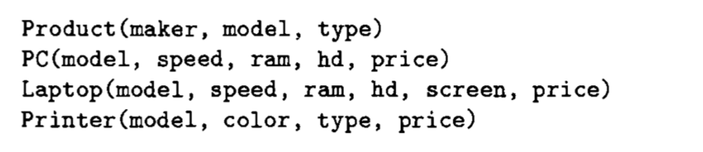

1. **Find the average speed of PC’s.**

SELECT AVG(speed)

FROM PC;

1. **Find the average speed of laptops costing over $1000.**

SELECT AVG(speed)

FROM Laptop

WHERE price > 1000;

1. **Find the average price of PC’s made by manufacturer “A”.**

SELECT AVG(price)

FROM PC, Product P

WHERE PC.model = P.model AND P.maker = ‘A’;

1. **Find the average price of PC’s and laptops made by manufacturer “D”.**

SELECT AVG(price)

FROM (

SELECT AVG(PC.price)

FROM PC, Product P

WHERE PC.model = P.model AND maker =’D’

UNION

SELECT AVG(L.price)

FROM Laptop L, Product P

WHERE L.model = P.model AND maker =’D’

);

1. **Find, for each different speed, the average price of a PC.**

SELECT speed, AVG(price)

FROM PC

GROUP BY speed;

1. **Find for each manufacturer, the average screen size of its laptops.**

SELECT maker, AVG(screen)

FROM Laptop L, Product P

WHERE P.model = L.model

GROUP BY maker;

1. **Find the manufacturers that make at least three different models of PC.**

SELECT maker

FROM Product P, PC

WHERE P.model = PC.model

GROUP BY maker

HAVING COUNT(~~distinct~~(P.model)) >= 3;

1. **Find for each manufacturer who sells PC’s the maximum price of a PC.**

SELECT maker

FROM Product P, PC

WHERE P.model = PC.model AND price >= ALL (SELECT price FROM PC)

GROUP BY maker;

1. **Find, for each speed of PC above 2.0, the average price.**

SELECT speed, AVG(price)

FROM PC

WHERE speed > 2.0

GROUP BY speed;

1. **Find the average hard disk size of a PC for all those manufacturers that make printers**

SELECT AVG(hd)

FROM PC, Product P

WHERE PC.model = P.model AND maker IN (SELECT maker FROM P, Printer Pr WHERE P.model = Pr.model);